Error metrics for skewed datasets:
- Challenges with Skewed Data: In scenarios where the ratio of positive to negative examples is heavily skewed, traditional error metrics like accuracy may not effectively gauge the performance of a machine learning model.
- Example of Rare Disease Detection: Consider a binary classifier for detecting a rare disease, where only 0.5% of patients have the disease. Achieving a 99% accuracy may seem impressive, but a simple algorithm that always predicts negative (y=0) can achieve 99.5% accuracy.
- Interpreting Error Rates: It becomes challenging to interpret error rates when dealing with imbalanced datasets. For instance, a model with a 1% error rate might seem worse than one with a 0.5% error rate, but it could still be more useful if it correctly identifies some positive cases.
- Choosing the Best Algorithm: Comparing models based solely on error rates can be misleading. An algorithm with a lower error rate might be overly conservative, missing positive instances entirely, while another with a slightly higher error rate could provide more actionable insights by identifying some positive cases.
- Need for Contextual Evaluation: It's essential to consider the practical implications of model performance in specific applications. A slightly higher error rate might be acceptable if the model can still identify some positive instances, making it more useful in real-world scenarios.
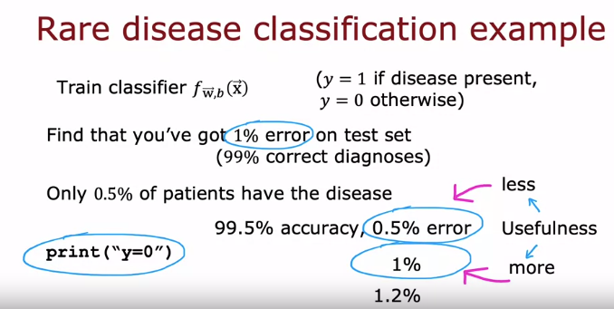

Confusion Matrix:
- Importance of Using Different Error Metrics: Traditional error metrics like classification accuracy may not be suitable for evaluating machine learning algorithms on imbalanced datasets. Instead, precision and recall offer a more nuanced assessment, especially for rare classes.
- Construction of Confusion Matrix: A confusion matrix is a 2x2 table that summarizes the performance of a binary classifier. It includes true positives, true negatives, false positives, and false negatives.
- Definition of Precision: Precision measures the accuracy of positive predictions made by the model. It is calculated as the ratio of true positives to the sum of true positives and false positives.
- Definition of Recall: Recall quantifies the ability of the model to capture all positive instances in the dataset. It is computed as the ratio of true positives to the sum of true positives and false negatives.
- Illustrative Example: Consider a classifier for a rare disease detection task. With 15 true positives, 5 false positives, and 10 false negatives, the precision is 75% and the recall is 60%.
- Interpretation of Precision and Recall: Both precision and recall help assess the usefulness of the model's predictions. A balance between high precision (positive predictions are accurate) and high recall (positive instances are correctly identified) is desirable.
- Detecting Uninformative Algorithms: Precision and recall metrics can reveal if the model is simply predicting one class all the time, which renders it ineffective.
- Significance of Precision and Recall: In scenarios with imbalanced classes, precision and recall offer insights into the model's performance, ensuring that it provides meaningful predictions for the rare class.
- Motivation Behind the Term "Recall": Recall captures the ability of the model to identify positive instances from the entire population. It emphasizes the importance of correctly diagnosing all individuals with the rare condition.
- Utility of Precision and Recall: These metrics aid in evaluating the predictive power of machine learning algorithms, especially when dealing with imbalanced datasets or rare classes. They provide a comprehensive understanding of the model's effectiveness beyond simple accuracy measures.
True Positive: because you predicted positive and it was true there's a positive example.
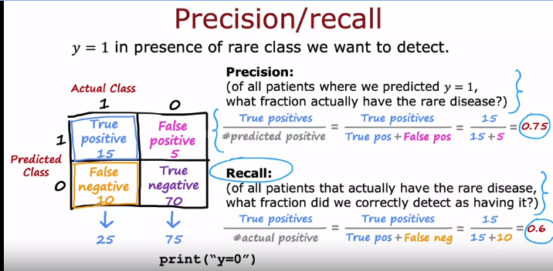

Precision vs. Recall Trade-Off
- Ideal Scenario for Learning Algorithms: In an ideal scenario, we desire high precision and high recall. High precision ensures accurate positive predictions, while high recall ensures the correct identification of positive instances.
- Thresholding in Logistic Regression: Logistic regression outputs probabilities between 0 and 1. By setting a threshold (e.g., 0.5), we predict class 1 if the probability is above the threshold, else class 0.
- Precision-Recall Trade-off: There's often a trade-off between precision and recall. Adjusting the threshold impacts both metrics. Raising the threshold increases precision but reduces recall, and vice versa.
- Impact of Threshold Adjustments:
  - Higher Threshold: Raises precision but lowers recall. Useful when confident predictions are crucial.
  - Lower Threshold: Reduces precision but increases recall. Suitable when avoiding false negatives is paramount.
- Example:
  - Disease diagnosis: High precision crucial to avoid unnecessary treatment, even if it means missing some cases.
  - Fraud detection: High recall crucial to catch most fraudulent transactions, even if it means some false positives.
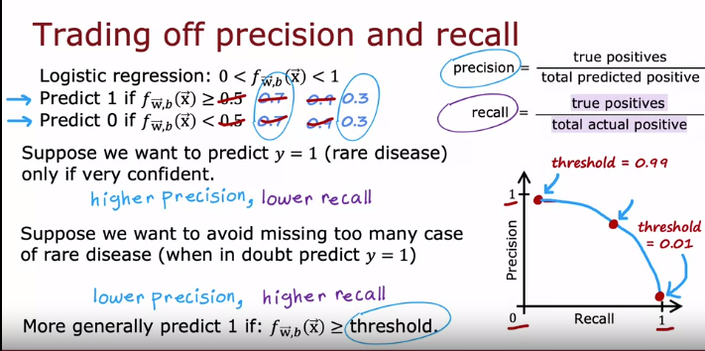

F1-score
- F1 Score as a Combined Metric: The F1 score is used to automatically balance precision and recall, offering a single metric for evaluating algorithms.
- Challenge with Precision and Recall: Evaluating algorithms based on precision and recall separately can be challenging when comparing multiple algorithms, especially if one is better on precision while another is better on recall.
- Combining Precision and Recall: Taking the average of precision and recall is not recommended due to its inability to properly account for very low values of either metric.
- Definition of F1 Score: The F1 score combines precision and recall by computing the harmonic mean of the two, giving more emphasis to the lower value between them.
- Formula for F1 Score: The F1 score is computed as the inverse of the average of the inverses of precision and recall.
- Interpretation of F1 Score: A higher F1 score indicates better balance between precision and recall, with emphasis on the lower value. It helps identify the algorithm with the best overall performance.
- Example Calculation: For three algorithms, the F1 scores are computed, with Algorithm 1 having an F1 score of 0.444, Algorithm 2 of 0.175, and Algorithm 3 of 0.0392.
- Emphasis on Smaller Values: The harmonic mean, or F1 score, emphasizes smaller values more, providing a fairer assessment of an algorithm's performance.

